**Design document**

BR00190- Functionality to assign multiple documents to a material number or configuration

Table of Contents

Change request description 3

High level Design 3

Low Level Design 3

Sample Design 4

Assumption 4

# Change request description:

To be able to attach documents which are representing the actual product configuration and not a generic one. Furthermore, to able to attach more than one document to a product configuration.

To give the user an option to specify or point to documents based on the configuration result.

# High level Design:

Multi-Document Upload Enabled for Configurable & Formula Based Products

1. Create a new table which needs to have MDL_ID, CharacteristicsName, CharacteristicsValue, PartNumber, DocumentName, DocumentLocation, DocumentDescription, DocumentFormat.
2. In the Maintenance tab->Bulk Update Screen-> A new option ‘Configurable_Documents’ is added in the Data Source dropdown for the Configurable and Formula based products.
3. On selection of the ‘Configurable_Documents’ option, upload the excel spreadsheet by filling all the values.
4. The uploaded documents will be displayed for each characteristics values as line item.
5. In the configurator.aspx page, on page load based on the characteristics value the documents with a hyperlink will be displayed.
6. In the configuratorbom.aspx page, on page load based on the characteristics value the documents with a hyperlink will be displayed.
7. In the cart.aspx page, documents with a hyperlink will be displayed based on the selected characteristics value.
8. In the summary.aspx page, documents with a hyperlink will be displayed based on the selected characteristics value.
9. If documents are not available for the selected characteristics value, the hyperlink will not be displayed in all the pages (Configurator.aspx, ConfiguratorBOM.aspx, Cart.aspx and Summary.aspx).

# Low Level Design:

Multi-Document Upload Enabled for Configurable & Formula Based Products

1. Create a new table in eConfig Database like below picture.

Table Name: CF_ConfigurableDocuments

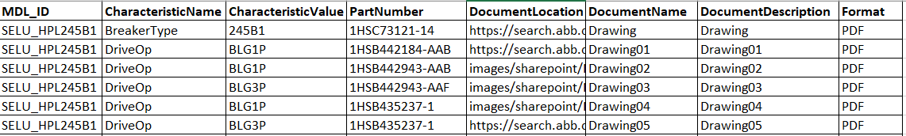

1. Maintenance Tab -> Bulk Update screen

* A new option is added into the Data Source dropdown for the selection of Configurable & Formula based Products.
* The sample excel template can be downloaded by clicking the button ‘Download Excel Template’.
* After filling all the document details in the spreadsheet, it can be uploaded into the server by clicking the button – Choose file under ‘Upload to Server’ and after that click on ‘Commit Changes’ button.
* Once the data is uploaded, it can be viewed by clicking the ‘Preview data’ button.
* Once the new data is uploaded, existing data in the table will be deleted and new data will be saved in the table.
* MDL_ID, CharacteristicsName, CharacteristicsValue, DocumentName, DocumentLocation, DocumentDescription & Format and mandatory values.

1. Configurator.aspx page (Characteristics selection)
   * On page load, the document’s will be displayed for each characteristic’s value.
   * On change of the characteristics value in the drop down the documents will be changed.
   * If a document is not available for the selected characteristics value, the document hyperlink will not be displayed.
   * On click of the ‘Document(s)’ hyperlink the document name will displayed as hyperlink.
   * On click of the document name hyperlink, the drawing will be displayed in the new window.

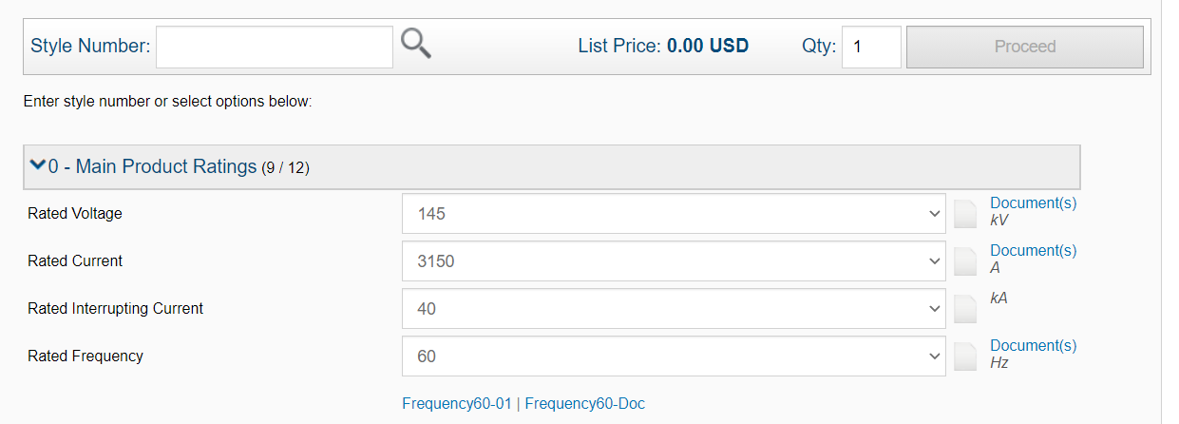

figure a. configurator.aspx/configuratorbom.aspx page

1. Cart.aspx page (standalone version)
   * On page load, the document name hyperlink will be displayed for each characteristic’s value.
   * On click of the document name hyperlink, the drawing will be displayed in the new window.
   * If a document is not available for the selected characteristics value, the document hyperlink will not be displayed.
2. Summary.aspx page (apttus version)
   * On page load, the document name hyperlink will be displayed for each characteristic’s value.
   * On click of the document name hyperlink, the drawing will be displayed in the new window.
   * If a document is not available for the selected characteristics value, the document hyperlink will not be displayed.

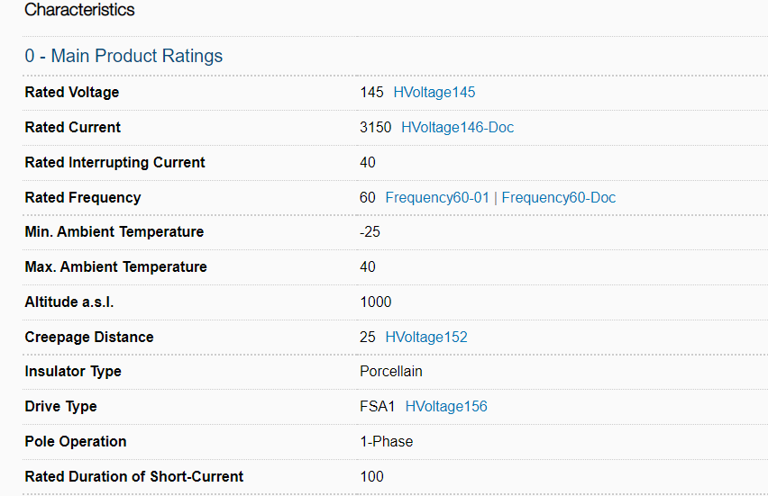

figure b. cart.aspx/summary.aspx page